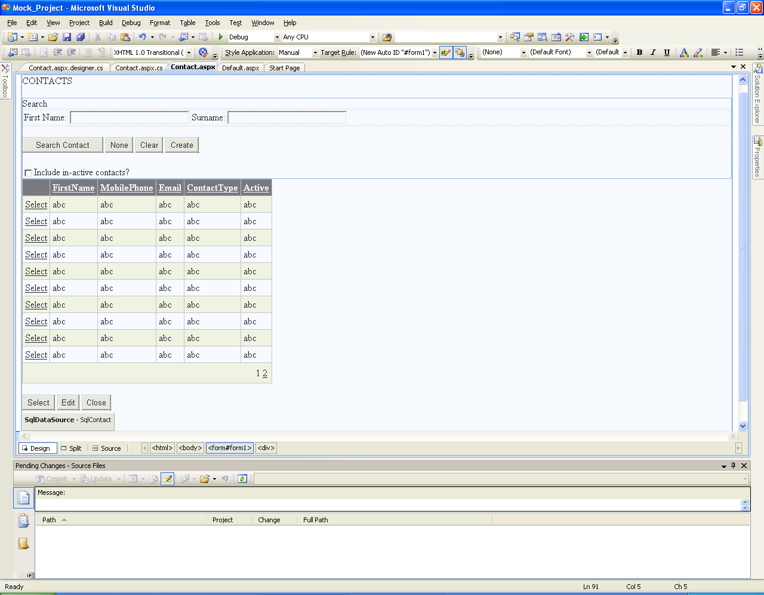

*Figure 1: Contact List*

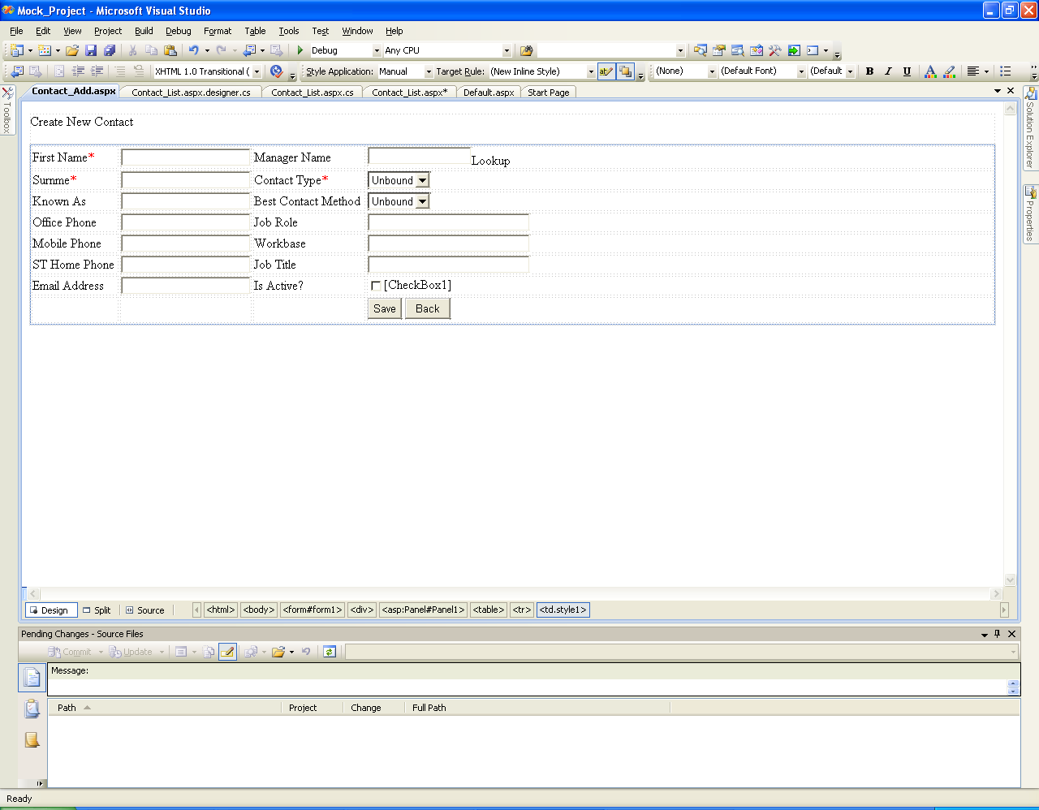

*Figure 2: Create new contact (Add Contact)*

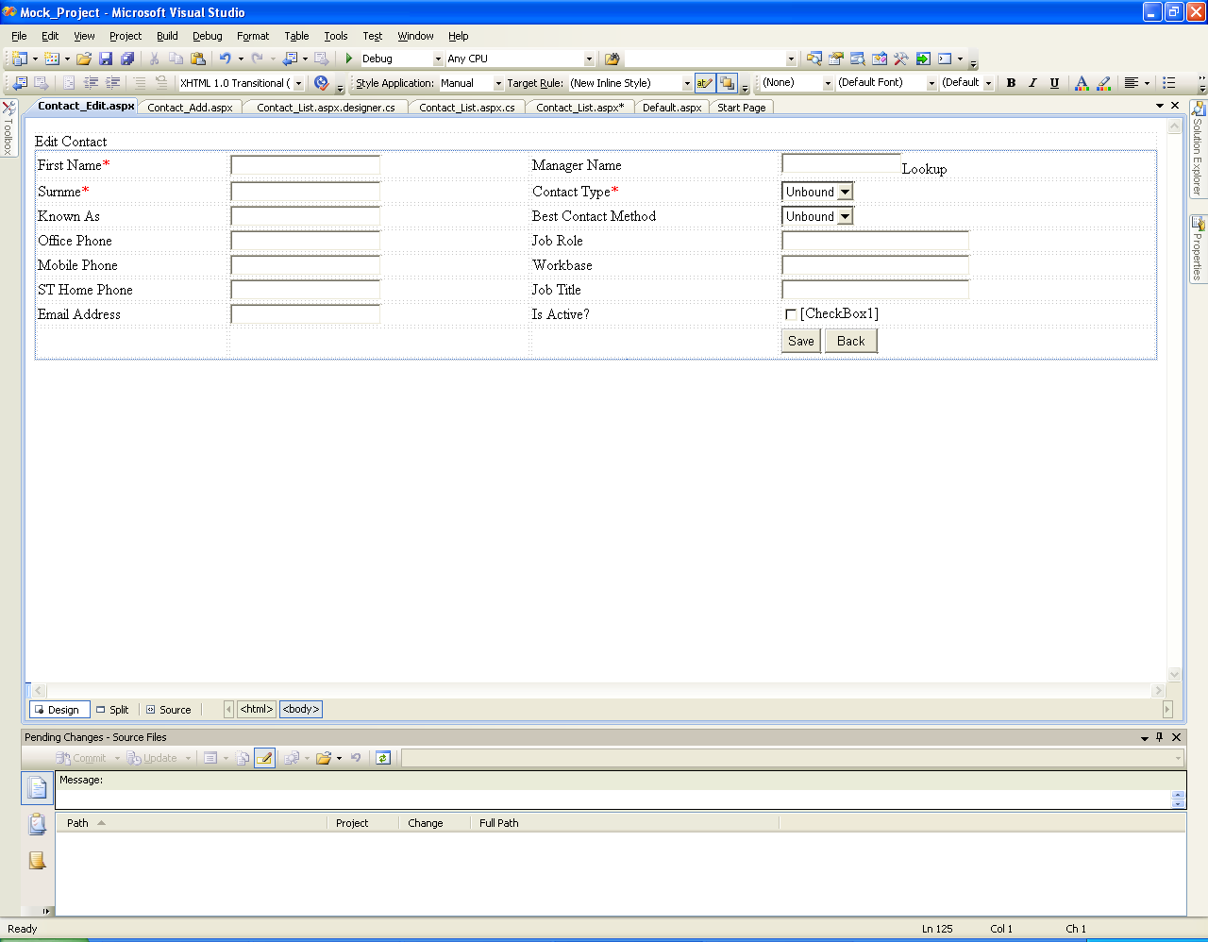

*Figure 3: Amend Contact (Edit Contact)*